ANMOL VERMA

Software Development Engineer

+91 7289879110 anmol6an@gmail.com /linkdin.com/in/amit-tewatia Gurgaon,Haryana

# EXPERIENCE Junior Software Engineer

Zimyo Consulting Pvt. Ltd. July 2022 - Present

Working on the HRMS product to adding new Features and on stability.

Responsive Web Design and Code Optimization and Performance Improvement.

Integrated RESTful APIs to fetch and display dynamic content.

Implemented routing using React Router for creating a multi-page user experience.

Improved application performance by optimizing components, reducing unnecessary renders, and implementing lazy loading.

Collaborated closely with UI/UX designers and backend developers to implement seamless user experiences.

Integrated the biometric process automatically. Implemented the new feature on web MANAGE(internal product) portal for calling to customers.

Implemented new document section in Documents module like HR Documents.

Implemented probation report or trip reports in Report directory.

Designed and Developed My team module in ESS side Implemented PIP module in Admin or ess both sides.

# Junior Software Engineer (internship)

## Bytesbrick infosystem Pvt. Ltd may 2022 - july 2022

Collaborated with the development team to design and develop user-friendly web applications.

Translated project requirements into clean, efficient, and maintainable HTML, CSS, and JavaScript code. Implemented responsive web designs and ensured cross-browser compatibility.

Conducted thorough testing and debugging of web applications to identify and resolve issues.

Assisted in the maintenance and updates of existing websites and web applications.

Stayed up-to-date with the latest web development trends and technologies, proposing innovative ideas to enhance user experience.

Participated in code reviews and knowledge-sharing sessions, contributing to a collaborative team environment.

# EDUCATION

Graduation  Aug 2015 - may 2019

Btech

## Rawal Institutions ,faridabad

HIgh School  2014 - 2015

Rawal Convent School (CBSE)

Grade - 70 %

## Ballabgarh,faridabad

Rawal Senior Secondary School

Matriculation  2013 - 2014

Grade - 87.5 %

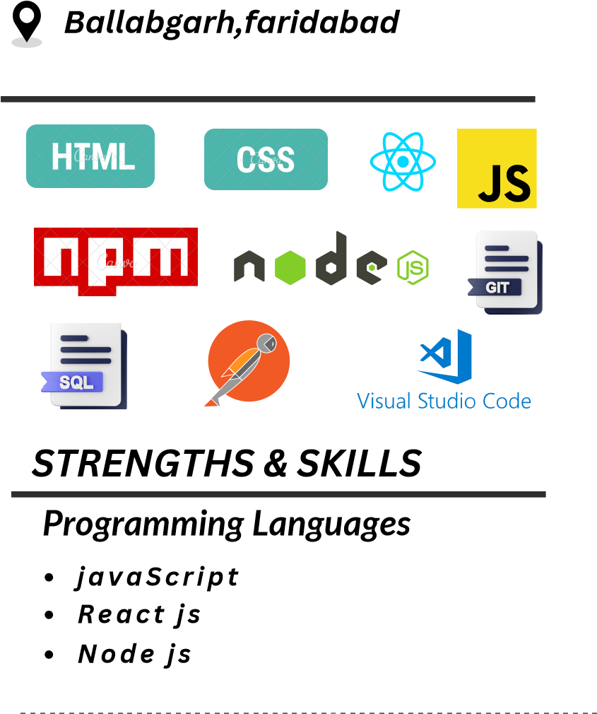

## Technologies & Frameworks

HTML

CSS

Restfull

Material-UI

GitHub

Tools & Database

SQL

Postman

Git

VS code